**Lesson11 Azure Storage Snapshot**

**Notes: -**

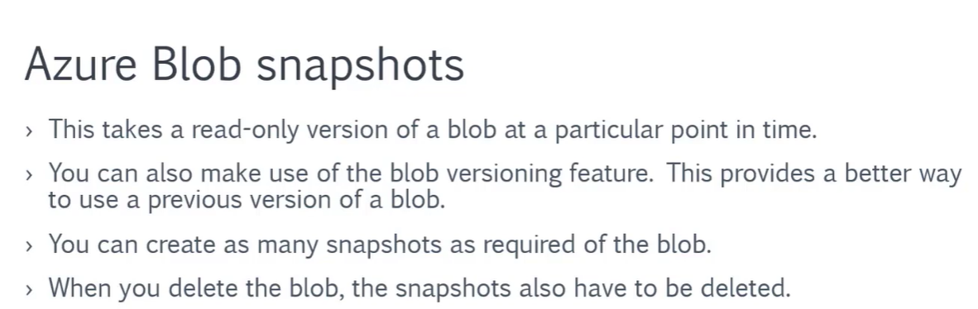

**(You can restore blob by using snapshot, and you can delete snapshot, but if you want to delete blob you have to delete snapshot with him)**

**1-with using blob snapshot, you can use it to restore the previous version of snapshot**

**(click on the blob and then click on the create snapshot)**

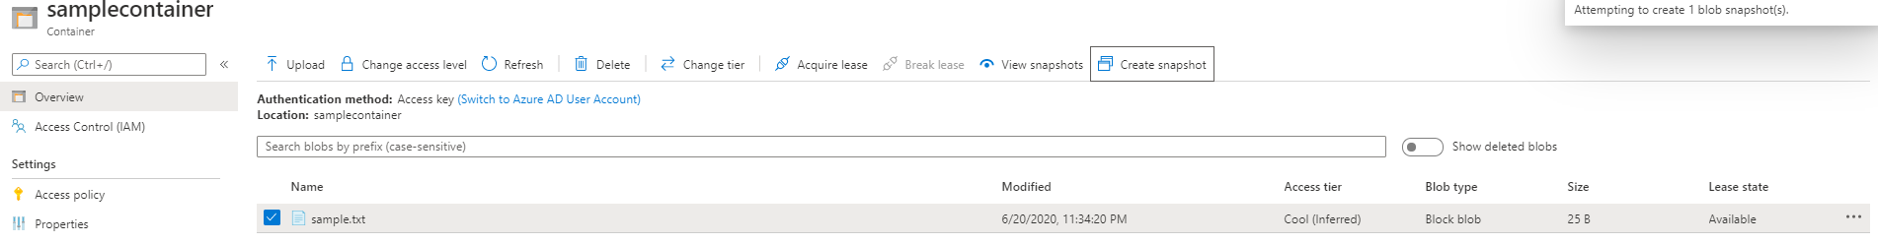

**2-on the azure container > blob (you can update the blob)**

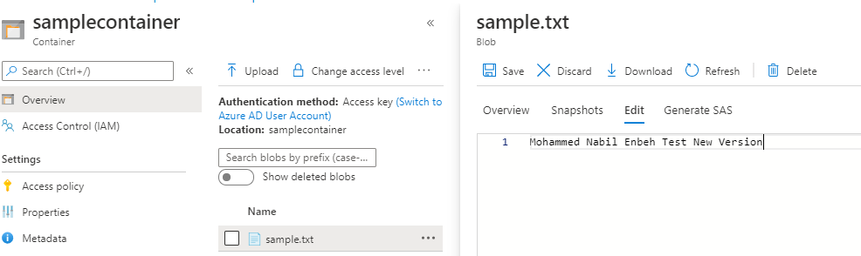

**3-on azure Storage > container > right click on blob > view snapshot**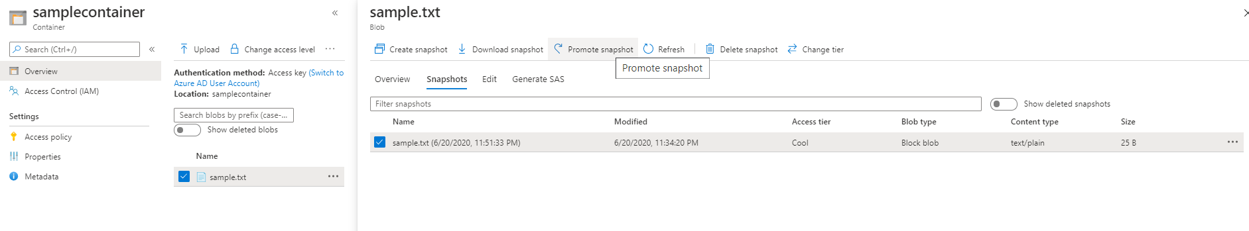

**(you will see that it will restore the previous version)**